Author-Centred Approach To Authoring: A Necessity[a necessity]

Olivier Burdet (Olivier.Burdet@epfl.ch), Aurelio Muttoni (Aurelio.Muttoni@epfl.ch),
Jean-François Perret (perretj@lu.unisi.ch)
IS-BETON, EPFL, GC B, CH-1015 Lausanne
i-structures.epfl.ch

Keywords : Authoring, editing, sustainability
The creation of content for an on-line course is a challenging task for all persons involved. Because of the technical nature of web-based learning, the role of authors often becomes less central in the preparation process. This is unfortunate, and should not be the case. The approach proposed in the paper shows how the entire preparation process can be reorganized to place the authors of the course material at the center of the preparation of an e-learning course.
Cet article a été publié en 2003 pour la conférence INCEE. A part l’ajout de ce paragraphe, un redimensionnement des figures, l’inclusion du protocole https et une nouvelle traduction en ASP au lieu de PHP, le texte n’a pas été modifié.

1. Authoring is an art[authoring is an art]
Authoring is an art that has been only been mastered by a few since the invention of writing, and probably even before. Telling a story or teaching a lesson are not gifts that everyone receives at birth, nor simple trades that all learn in school. It is not a sufficient to put some ideas together and to come up with a decent layout. We have all read some excellent work, and felt compelled by the class, the ingenuity and the style radiating from the author. We also all have read almost unbearable material that was possibly very well laid out, but completely lacked substance and style. While the appreciation of a given author is also a matter of personal taste, it is absolutely clear that only a good author can come up with truly interesting material.
This is not only true in the case of literature, but it also applies to the general field of academic authoring. While publication throughput has been decreed as a paramount criterion for the evaluation of performance of researchers, it remains clear that the most important factor is the quality of the publications, not the minimum quality required for publication, but the intrinsic quality of the work that lies underneath it.
The rules of good have slowly evolved over time. With the technical changes from stone engraving to writing on papyrus to writing on parchment to writing on paper with a pen, then with a typewriter, then with a computer, the form of the text produced has progressively changed over the years. But with the introduction of new media, such as newspapers, or more recently the web, the writing style undergone some radical changes. Some people talk about a semiotic revolution. More specifically, the classical relationship between text and illustrations has been deeply changed (Peraya, 1998). In the same manner that lines in a newspaper are much shorter than in a typical book, in order to be read more easily, text published on the Internet needs to be presented in a different fashion than in other media; a completely new approach to the layout of text is needed. In general, it needs to be much more concise, perhaps with underlying links leading the reader to further reading.
Most people, up to that day, have more difficulties concentrating on text presented vertically on a computer screen than on a sheet of paper. Therefore, the formulation of this type of material, while remaining precise, needs to be simplified and formulated in a more direct fashion.
It is also necessary to take into account the general evolution of reading practices. Reading of electronic material increasingly becomes a matter of consulting useful material, much more than a sequential reading (Perriault, 2002). This will influence the preparation of course material, which in some occasions will need to become a reference document instead of a textbook.
When writing a newspaper article, the author needs to compete with surrounding articles and with the small amount of time devoted to reading his article. When writing an article for the web, the author faces much stronger competition, not only within the medium itself –other, more interesting web pages– but also within the computer –other programs, most especially games. This difficulty is even greater for on-line learning, as it is a demanding task, from which we know that it is easy to become distracted.

2. Authoring is hard work[authoring is hard work]
Authoring a virtual course is thus a very different experience for an academic than writing course scripts, textbooks or scientific articles. Often, this requires the complete reformulation of otherwise available material. Once again, not only the scientific competence of authors, but also their willingness to adapt to new conditions are required. Instead of enjoying the freedom offered by electronic media to produce unlimited amounts of materials, authors need to concentrate on identifying the most important contributions in each lesson and to make sure that these concepts come across clearly. Only in related materials (that by far not all students will read and understand) may they use the freedom to add larger amounts of material. As always, authoring remains the art of carefully putting together concepts and ideas in a tight and understandable package.
The process of producing material for a web-based course is also often frustrating, because if requires very qualified persons – the authors – to take into consideration entirely new ways of operating, sometimes with more restrictions than they are used to in the process of producing other text material : while the use of color is free on the web, some other layout techniques such as headers and footers, absolute placement of elements, multi-column text are indeed more complicated to produce than in a typical word-processing program. While the flexibility of HTML tables is very large, they have very limited features to enhance them (customized borders for instance), or these features do not produce uniform content in all browser-platform configurations.
This problem is often avoided by having the authors produce their material in their usual fashion (text, slides, etc.) and then have it translated into HTML by specialized personnel. This process, while efficient for the initial creation of the material, rapidly becomes unmanageable if the authors desire to regularly modify their material.

3. The editing process is iterative[editing is iterative]
In general, and this is more and more the case, material of any kind is not produced in a single session. Instead, a first version is produced, discussed, and then modified. The second version will also be criticized and enhanced. The editing process is thus, for most authors, an iterative one. Course material often goes through many iterations over several years before being eventually transformed into a textbook. This textbook will in turn need a new edition, and so on.
In our opinion, the elaboration of an electronic course material must follow a similar process. It will need to evolve and adjust in accordance to the experience gained in the use of the course. This is actually the function of the field tests recommended by the Swiss Virtual Campus. Of course, the short time period devoted to one or two tests is too short to really check the relevance of the chosen writing options.
It can also be noted that a flexible editing process will not only be used to correct and enhance previous versions of the course, but that it also enables the teachers to make choices and additions to accommodate partial changes of content, that all teachers perform over the years. It is therefore necessary to examine what editing strategies and techniques are most appropriate to enable teachers to keep their course material “alive” by making, at the appropriate time, all needed changes to the course material in an easy and at inexpensive manner.
Because producing material for the web requires that this material be judged by is appearance on the web, it is desirable that a web version of the content be produced for each iteration. This can become time- and resource-consuming. Recent incarnations of the mainstream word processing programs allow to directly save documents into a web format, but the result of this translation is not suitable, as it only aims at producing a web page that looks exactly as a paper page.
It is now time to ask this simple question: how can we help authors to best do their job? One way that can be most profitable to help authors is to give them a way to keep working within a familiar environment, in which they can concentrate on the creation, edition and revision of their material.
break

4. From Word to HTML[Word->HTML]
The solution developed within the i-Structures project of the Swiss Virtual Campus takes a practical approach to the problem of repeatedly creating material for the web. Considering that most authors, and this is the case for all authors within the project, use Microsoft Word for basic text-processing, a set of macro was written to automatically convert the content of a Word document into a series of related web pages. These web pages can then be evaluated and, if it is not satisfactory, the material can be further edited in Word by the author. The control of the document thus never really leaves the author, except for the short period of time during which it gets processed into web pages.
This process allows a very simple and transparent editing process for the material: the Word file contains all text, links and pictures for the pages. Special paragraph styles are used to identify various parts of the lesson: text, lists, questions, figures and tables. Additional linked material, such as videos, sounds, applets etc. are introduced within the word file as snippets of HTML code. Careful color-coding of the various styles makes it very easy for “normal authors” not to alter this code, which preserves it for the next translation.

5. Example
The two figures below show a part of the screen as it is seen when using the word-processing program, and then the resulting appearance of the web page. The page itself is rendered using a specially developed HTML style sheet. The author does not see a WYSIWYG version of the future web page, but, since the translation process occurs rapidly, it is possible to frequently control the result of the translation. Experience shows that only a couple adjustments are needed to obtain a suitable result, as for instance the introduction of a “No break” instruction to avoid separating parts of the material that need to be shown together.
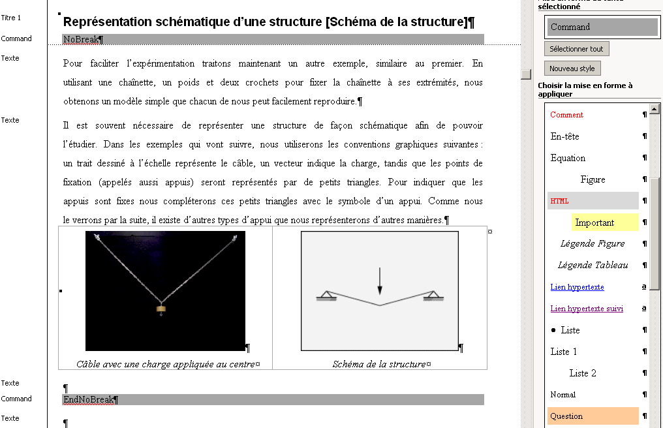
Example of a Word document using the special styles
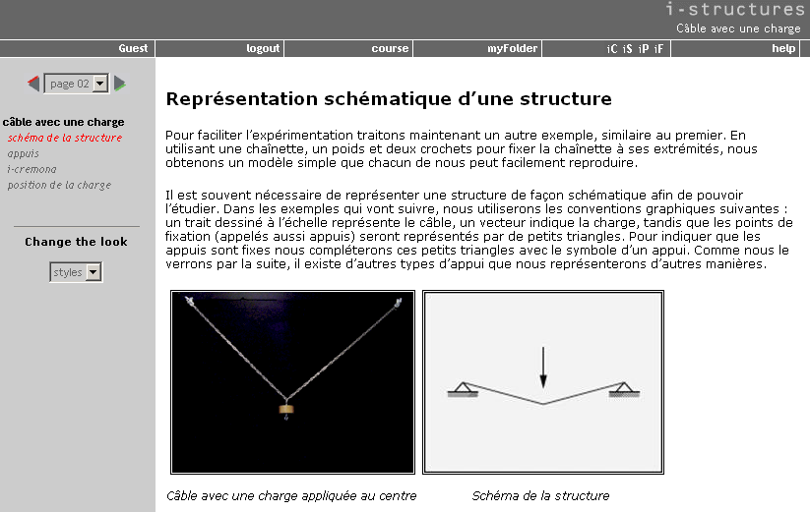
Web appearance of the fragment of text from the previous figure

6. Practicability vs. sustainability?[practicability vs sustainability]
It has often been stated that large platforms offer the best solution to ensure sustainability of web-based material. This is mainly due to the fact that these platforms are professionally supported and developed. The development of course material for these platforms, however, needs to be made outside of the platform, typically using an HTML editor. More recently, the use of Content Management Systems has allowed bypassing this step, often with strong limitations in the layout possibilities.
The solution of working from Word files has several advantages regarding the durability of the produced material, however. Considering that the program itself has been widely available for more than 10 years, and that it is controlling a large share of the market, it is likely to remain a strongly supported product for many years. More importantly, the nature of the material produced, mostly text and figures, carefully tagged using paragraph styles, is already an halfway XML document. Indeed, the macros developed within the project could easily be modified to produce XML code, and this has been envisioned as a development for future versions.
In the same manner, the target “platform” of the macro could be changed to accommodate other environments than the current custom-developed support environment based on PHP scripts. This way, the authors are assured that their material will remain available and editable (not only for use on the Web) in the future, but also that it will be possible in the future to port it to other publishing environments without excessive work, more specifically, without any additional work from the authors. The only persons involved in the adaptation to a new environment would be programmers working on the translation process from tagged Word documents to HML pages, a rather simple and well defined task.
This approach was initially chosen by the project because it greatly simplifies the translation of material from one language into another (the lessons will be prepared in a least three languages): the person translating the material most likely also uses Microsoft Word, and only needs to translate the material while paying attention not to alter the applied paragraph styles. This is a simple task that allows separating the process of translation from that of web publishing.
What is the trade-off from this approach? As in all standardized systems, it is clear that some special layout features from HTML are not supported, and thus that the layout will need to follow the rules defined within the style sheet. This can also be seen as an advantage, because it leads to a greater consistence in the presentation of the material. Authors and graphic designers are involved in the definition and development of the feature set to make sure that most desirable features are implemented to reach a pleasing and efficient interface. The result can be seen on the i-structures site at https://i-structures.epfl.ch
Readers interested in seeing firsthand how the Word document looks, and what the output of the conversion is can look a at a web version of this article at the address https://i-structures.epfl.ch/articles/authoring-1-01_e.asp
The Word version of the article is also available for downloading: https://i-structures.epfl.ch/articles/authoring-1_e.doc

7. Conclusions[conclusions]
Authors are truly the richest part of the Swiss Virtual Campus project. Often, it is the first time that professors from various universities collaborate for a long period of time on an educational project. It is therefore essential that the fruits of this collaboration be carefully collected and that their preparation happens with the least obstruction of the iterative cooperative edition process. The solution proposed, based on a custom-made Microsoft Word template and a set of macros used to translate the tagged Word document into a set of related HTML pages has proven to be very efficient in the preparation, iterative edition and translation of the course material. The proposed methodology could easily be applied to other target publication environments, such as the major platforms.

Peraya, D. (1998). Une "révolution sémiotique". Les cahiers pédagogiques, 362, 26-28.
Perriault. J. (2002) L'accès au savoir en ligne. Paris: Odile Jacob.

